**Index**

1. **Introduction**  
   1.1. Project Overview  
   1.2. Purpose  
   1.3. Target Audience  
   1.4 Project Small Info  
   1.5 System Requirement
2. **Aim/Objective**  
   2.1. Primary Aim  
   2.2. Specific Objectives
3. **Features of Health Care App**  
   3.1. User Side Features  
   3.2. Admin Side Features
4. **Technology Used**  
   4.1. Development Environment  
   4.2. Programming Languages  
   4.3. Database Management  
   4.4. APIs and Libraries  
   4.5. Protocols  
   4.6. Permissions
5. **Limitations of Existing Technology**
6. **Advantages of Current Technology**
7. **System Flow Chart**  
   7.1. User Flow  
   7.2. Admin Flow
8. **E-R Diagram (Entity-Relationship Diagram)**  
   8.1. Entities and Attributes  
   8.2. Relationships
9. **DFD (Data Flow Diagram)**  
   9.1. Level 0 DFD (Context DFD)  
   9.2. Level 1 DFD  
   9.3. Level 2 DFD
10. **Database Design**  
    10.1. User Table  
    10.2. Doctor Table  
    10.3. Medicine Table  
    10.4. Cart Table  
    10.5. Medicine Search History Table  
    10.6. Doctor Search History Table  
    10.7. Medicine Order Table  
    10.8. Notification Table
11. **Screen Shots (Descriptions)**  
    11.1. User Screens  
    11.2. Admin Screens
12. **System Testing**  
    12.1. Types of Testing  
    12.2. Example Test Cases
13. **Limitations of Current System**
14. **Future Enhancement**

**1. Introduction**

**1.1. Project Overview**

The "Health Care App" is a comprehensive mobile application designed for the Android platform, aiming to serve both general users and administrative personnel. This application acts as a digital health companion, providing users with easy access to health-related information, medicine searches, doctor details, an AI-powered chat for health queries, and local emergency services. Simultaneously, it offers a robust administration panel for managing doctors, medicines, users, and orders within the system. Developed using Android Studio, Java, and SQLite, and integrating external APIs like OpenRouter and Newsdata.io, this app provides a complete ecosystem for basic health management and administrative oversight.

**1.2. Purpose**

The primary purpose of the Health Care App is to make health-related services and information more accessible and manageable. For users, it simplifies the process of finding health information, discovering medical professionals, and ordering medicines. For administrators, it provides an efficient system to maintain and update the app's core data, ensuring the information provided to users is current and accurate.

**1.3. Target Audience**

The application targets two main user groups:

* **General Users:** Individuals seeking easy access to health information, looking for doctors, searching for medicines, or needing quick health advice through an AI chatbot. This includes people who want to track basic health metrics or find nearby medical facilities.
* **Administrators:** Personnel responsible for managing the content and operational aspects of the application, such as adding new doctors, updating medicine details, managing user accounts, and processing medicine orders.

**1.4. Project Small Info**

|  |  |
| --- | --- |
| Field | Details |
| Project Title | Health Care App |
| Project Type | Mobile Application Development (Android) |
| Developed Using | Android Studio, Java, XML, SQLite |
| APIs Used | OpenRouter, Newsdata.io |
| Protocols Used | SMTP (for sending mails/notifications) |
| Database | SQLite (local storage of health data, records, users) |
| Project Sides | Admin, User Side |
| Key Features | Doctor Search, Medicine Orders, Emergency Help, Health Records Management |
| Purpose | To make healthcare services easily accessible and faster for users |

**1.5. System Requirements**

|  |  |
| --- | --- |
| Requirement Type | Details |
| Operating System | Windows 10 / 11 (for development), Android 8.0 (Oreo) or above (for app) |
| Development Tool | Android Studio |
| Programming Language | Java, XML |
| Database | SQLite |
| API Integration | OpenRouter, Newsdata.io |
| Protocols | SMTP |
| Hardware (Dev System) | Minimum i5 Processor, 8GB RAM, 5GB free storage |
| Hardware (Mobile) | Android Phone with 2GB RAM, 50MB free storage |
| Internet Requirement | Active Internet Connection for API & SMTP features |

**2. Aim/Objective**

**2.1. Primary Aim**

The main aim of the Health Care App is to develop an intuitive, feature-rich Android application that acts as a central hub for health information and services, catering to both end-users and administrators. It seeks to improve access to health-related resources and streamline administrative tasks within a mobile environment.

**2.2. Specific Objectives**

1. **User-Friendly Interface:** To design and implement a clean, intuitive, and easy-to-navigate user interface for both user and admin functionalities.
2. **Comprehensive User Module:** To provide users with capabilities such as secure sign-in/sign-up, profile management, medicine and doctor search, health tracking, AI-powered health chat, and order management.
3. **Robust Admin Module:** To enable administrators to efficiently manage doctors, medicines, user accounts, and track medicine orders through dedicated functionalities.
4. **Database Management:** To securely store and retrieve user data, doctor information, medicine details, cart items, search histories, and order information using SQLite.
5. **API Integration:** To successfully integrate external APIs like OpenRouter for AI chat functionalities and Newsdata.io for displaying real-time health news.
6. **Location-Based Services:** To integrate Google Maps functionality for locating nearby hospitals and medical stores.
7. **Communication Protocols:** To implement SMTP for essential features like password recovery via email.
8. **Error Handling and Validation:** To ensure data integrity and a smooth user experience through proper input validation and error handling mechanisms across the application.
9. **Security Measures:** To implement basic security features for user authentication and data protection.
10. **Educational Tool:** To serve as a practical demonstration of modern Android app development concepts, database design, and API integration for a college project.

**3. Features of Your Project**

The Health Care App is segmented into two distinct user experiences: the User Side and the Admin Side, each with its own set of functionalities tailored to their specific roles.

**3.1. User Side Features**

The user application provides a variety of features aimed at empowering individuals to manage their health information and access services conveniently.

* **Authentication & Profile Management:**
  + **Sign In/Sign Up:** Secure registration and login processes for new and returning users.
  + **Forgot Password:** A recovery mechanism via email (using SMTP) to reset forgotten passwords.
  + **User Info Collection:** A guided onboarding process (via View Pager) to collect essential user health data like Gender, Age, Blood Group, Height, Weight, Address, and Activity Level.
  + **Edit Profile:** Users can update their personal and health information.
* **Dashboard & Navigation:**
  + **Dashboard Activity:** The central hub after login, featuring a bottom navigation bar for easy access to Home, Medicine, Ai Chat (FAB), Health, and Profile sections.
* **Information & Search:**
  + **Home Fragment:** Displays personalized greetings, a search bar for medicines, quick access buttons for Doctors, SOS (ambulance), Nearby Hospital (Google Map), Nearby Medical (Google Map), trending E-News (via Newsdata.io API), and horizontal recyclers for Top 5 Medicines and Top 5 Doctors.
  + **Medicine Fragment:** Dedicated section for medicine browsing, searching, banner advertisements, popular products, and all available medicines listed in recyclers.
  + **Doctor Activity:** Dedicated section for doctor browsing, searching, banner advertisements, popular doctors, and all available doctors listed in recyclers.
  + **Medicine Search Activity:** Allows users to search for medicines by name, category, etc.
  + **Doctor Search Activity:** Allows users to search for doctors by name, job title, location, etc.
  + **Medicine/Doctor Search Result Activity:** Displays results from searches.
  + **Medicine Detail Activity:** Provides detailed information about a selected medicine, including description, price, rating, and expiry date.
  + **Doctor Details Activity:** Provides comprehensive information about a selected doctor, including job title, contact details (WhatsApp, Phone, Instagram), location, rating, and description.
* **Health & Wellness Tools:**
  + **Ai Chat Activity:** An interactive chatbot powered by the OpenRouter API (using mistralai/mistral-small-3.2-24b-instruct:free model) for answering health-related queries.
  + **Health Fragment:** Displays various health metrics such as Max Heart Rate (with a redirect to Heart Rate Activity), Blood Group, Age, Height, Weight, BMI, BMR, TDEE, and recommended daily water intake.
  + **Heart Rate Activity:** A dedicated screen to view or calculate heart rate related information.
* **Commerce & Orders:**
  + **Cart Activity:** Users can add medicines to a shopping cart, adjust quantities, and proceed to order.
  + **Your Orders (via Settings):** View past and current medicine orders.
* **Utilities & Settings:**
  + **Notification Activity:** Displays important alerts and updates for the user.
  + **Settings Activity:** Provides options for managing app preferences, viewing privacy policy, terms and conditions, accessing Top Doctor/Medicine lists, Ai Chat, Cart products, Your Orders, Notifications, Log Out, and Delete Account.
  + **Privacy Policy Activity:** Displays the app's privacy policy.
  + **Terms Conditions Activity:** Displays the app's terms and conditions.
  + **SOS Functionality:** A quick button on the Home screen to dial 108 for emergency ambulance services.
  + **Nearby Hospital/Medical:** Utilizes Google Maps to help users locate nearby hospitals and medical stores.

**3.2. Admin Side Features**

The administrator interface is designed for managing the application's core data and user interactions.

* **Authentication:**
  + **Admin Sign In Activity:** A dedicated login screen for administrators.
* **Admin Dashboard:**
  + **Admin Dashboard Activity:** The central control panel with a bottom navigation bar for Home, Medicine, Doctor, User, and Order management.
* **Monitoring & Overview:**
  + **Admin Home Fragment:** Provides an overview with card views showing Total Users, Total Doctors, Total Medicines. It also lists the 5 New Doctors and 5 New Users in horizontal and vertical recyclers, respectively.
* **Content Management (CRUD Operations):**
  + **Admin Medicines Fragment:** Allows administrators to search for medicines, view all medicines in a recycler view, add new medicines (via FAB), and update or delete existing medicines (by clicking on a recycler view item).
    - **Admin Add Medicines Activity:** Screen to add new medicine details.
    - **Update Medicines Activity:** Screen to modify details of an existing medicine.
  + **Admin Doctors Fragment:** Similar to medicine management, enabling search, viewing, adding, updating, and deleting doctor profiles.
    - **Admin Add Doctor Activity:** Screen to add new doctor details.
    - **Update Doctors Activity:** Screen to modify details of an existing doctor.
  + **Admin Users Fragment:** Allows administrators to search for users, view all user accounts, add new users (via FAB), and update or delete user profiles.
    - **Admin Create New Users Activity:** Screen to add new user details.
    - **Update Users Activity:** Screen to modify details of an existing user.
* **Order Management:**
  + **Admin Medicine Order Fragment:** Displays a list of all medicine orders.
  + **Admin Medicine Order Details Activity:** On clicking an order, administrators can view details and have an option to cancel the order. Cancelling an order deletes it from the database and sends a notification to the user.

**4. Technology Used**

The Health Care App is built using a modern Android development stack, integrating various tools, languages, and external services to deliver a comprehensive mobile experience.

**4.1. Development Environment**

* **Android Studio:** The official Integrated Development Environment (IDE) for Android application development. It provides tools for coding, debugging, performance profiling, and building Android apps.

**4.2. Programming Languages**

* **Java:** The primary programming language used for the backend logic, business rules, and interaction with the Android SDK.
* **XML (eXtensible Markup Language):** Used for defining the user interface (UI) layouts of the Android application, describing the structure and elements of each screen.

**4.3. Database Management**

* **SQLite:** An embedded relational database management system. It is used as the local, on-device database for storing all application data, including user profiles, doctor details, medicine information, cart items, order history, search history, and notifications.

**4.4. APIs and Libraries**

* **OpenRouter API:** Integrated for AI chat functionality. Specifically, it uses the mistralai/mistral-small-3.2-24b-instruct:free model to power the conversational AI.
* **Newsdata.io API:** Used to fetch and display real-time news articles, specifically for the "E-News" section on the user's home screen.
* **Volley:** An HTTP library from Google for fast and easy networking on Android, primarily used for network requests related to fetching news data.
* **Gson (Google Json):** A Java library used to convert Java objects into their JSON representation and vice versa. Essential for parsing JSON responses from APIs into Java objects.
* **Lottie:** A mobile library for Android and iOS that parses Adobe After Effects animations exported as JSON and renders them natively on mobile. Used for payment success animations, enhancing the user experience.
* **com.sun.mail:android-mail & com.sun.mail:android-activation:** Libraries that enable email sending capabilities within Android applications, specifically used for the SMTP protocol to send emails for password recovery.
* **Google Maps (Conceptual Integration):** While not explicitly listed as a dependency in build.gradle.kts, the description mentions "Nearby Hospital (Redirect On Google Map)" and "Nearby Medical (Redirect On Google Map)," implying integration with Google Maps for location-based services. This typically involves using the Google Maps SDK for Android.

**4.5. Protocols**

* **SMTP (Simple Mail Transfer Protocol):** Utilized for sending emails, specifically for the "Forgot Password" functionality to facilitate password reset by sending an OTP or reset link to the user's email address.

**4.6. Permissions**

The AndroidManifest.xml file specifies the necessary permissions for the application to function correctly and interact with device features and external networks.

* android.permission.ACCESS_NETWORK_STATE: Allows applications to access information about networks.
* android.permission.INTERNET: Allows applications to open network sockets, crucial for all API interactions (OpenRouter, Newsdata.io) and email sending.
* android.permission.CALL_PHONE: Allows an application to initiate a phone call without going through the Dialer user interface, used for the "SOS (Call 108 Ambulance)" feature.
* android.permission.READ_EXTERNAL_STORAGE: Allows an application to read from external storage, potentially used for image selection for profile pictures or medicine/doctor images.

**5. Limitations of Existing Technology**

When developing a mobile application, especially in the healthcare domain, it's important to be aware of the general limitations associated with the technologies and approaches commonly used. These are not necessarily direct limitations of *this specific project* but rather considerations for mobile health applications in general.

1. **Security Risks:** Mobile applications, particularly those handling sensitive health data, are vulnerable to security breaches if proper encryption and authentication mechanisms are not robust. Data stored locally or transmitted over networks can be intercepted.
2. **Scalability Challenges (for local databases):** While SQLite is excellent for local data storage, it does not inherently support real-time synchronization across multiple devices or a large number of users. For a widely adopted application, a centralized cloud-based database would be essential.
3. **Internet Dependency:** Many advanced features, especially those integrating with external APIs (like AI chat, news feeds, or cloud databases), require a stable internet connection. Limited or no connectivity can severely impair functionality.
4. **Platform Specificity:** Developing for a single platform (Android in this case) limits the app's reach to users on other operating systems (like iOS). Cross-platform development tools can address this but come with their own trade-offs.
5. **Data Accuracy and Reliability:** For self-reported health data (e.g., age, weight, activity level), the accuracy depends entirely on user input. AI chat responses, while helpful, should not replace professional medical advice. The source of news data (Newsdata.io) also needs to be reliable.
6. **Maintenance and Updates:** Keeping the application updated with the latest Android versions, security patches, and API changes requires continuous development effort. Neglecting updates can lead to compatibility issues or security vulnerabilities.
7. **Performance on Older Devices:** Applications with rich UIs, animations (Lottie), and heavy data processing might perform poorly on older Android devices with limited resources.
8. **App Store Compliance:** Adhering to strict guidelines for app store submission (Google Play Store) regarding privacy, data handling, and user experience can be challenging and requires careful attention.
9. **Privacy Concerns:** Handling personal health information (PHI) requires strict adherence to privacy regulations (e.g., HIPAA in the US, GDPR in Europe). Even for a college project, understanding these implications is crucial.

**6. Advantages of Current Technology**

The technology stack chosen for the Health Care App offers several advantages, especially for a college project, allowing for efficient development and demonstration of key mobile development concepts.

1. **Android Studio (IDE):**
   * **Comprehensive Toolset:** Provides a complete environment for coding, testing, and debugging, streamlining the development process.
   * **Official Support:** Backed by Google, ensuring regular updates, vast documentation, and a large community for support.
   * **Emulator/Device Testing:** Easy to test the app on various virtual and physical Android devices.
2. **Java (Programming Language):**
   * **Robust and Mature:** A well-established language with strong community support and extensive libraries, making it reliable for complex logic.
   * **Object-Oriented:** Facilitates modular and reusable code, improving maintainability and scalability (within the context of a single-client app).
   * **Android Native Language:** Offers direct access to Android's rich set of APIs and SDK features, ensuring optimal performance.
3. **XML (UI Layouts):**
   * **Declarative UI:** Allows for easy and visual design of user interfaces, separating UI logic from business logic.
   * **Flexible and Powerful:** Can create highly customized and responsive layouts for different screen sizes and orientations.
4. **SQLite (Local Database):**
   * **Lightweight and Embedded:** No server setup required, making it easy to integrate directly into the mobile application. Ideal for storing local, on-device data.
   * **Offline Capability:** Data can be accessed even without an internet connection, enhancing the app's usability for core features.
   * **Ease of Use:** Relatively simple to learn and implement for basic CRUD (Create, Read, Update, Delete) operations.
5. **OpenRouter & Newsdata.io APIs:**
   * **Feature Enrichment:** Rapidly adds advanced functionalities (AI chat, real-time news) without building them from scratch.
   * **Access to External Data/Services:** Leverages existing powerful external services, enhancing the app's value proposition.
   * **Demonstrates Integration Skills:** Provides a practical opportunity to learn and demonstrate API integration, a crucial skill in modern app development.
6. **SMTP (Email Protocol):**
   * **Standard Communication:** A universal and reliable protocol for sending emails, essential for features like password recovery and notifications.
   * **Accessibility:** Most users are familiar with email, making it a convenient channel for important communications.
7. **Volley (Network Libraries):**
   * **Efficient Network Handling:** Designed to manage network requests effectively, handling caching, request prioritization, and error management.
   * **Simplified Asynchronous Operations:** Makes it easier to perform network operations without blocking the main UI thread, ensuring a smooth user experience.
8. **Lottie (Animations Library):**
   * **Enhanced UI/UX:** Adds engaging and high-quality animations with minimal effort, significantly improving the app's visual appeal and user interaction.
   * **Small File Sizes:** Vector-based animations are lightweight, reducing app size and improving loading times.
9. **Android Permissions:**
   * **Controlled Access:** Allows the app to request specific functionalities from the device (e.g., internet, making calls) in a transparent way, enhancing user trust and security.
   * **System Integration:** Enables the app to seamlessly interact with core device features like dialing, network status, and file storage.

**7. System Flow Chart**

A system flow chart visually represents the sequence of operations and decisions within the application. Here, we'll describe the high-level flows for both the User and Admin sides.

**7.1. User Flow**

The user flow describes the journey a typical user takes when interacting with the application, from initial launch to accessing various features.

1. **Start App:** Application is launched.
2. **Splash Screen:** A brief introductory screen.
3. **Onboarding Screen:** (First time user) Guides user through initial app benefits.
4. **Login/Sign Up Screen:**
   * **New User:**
     + Clicks "Sign Up with Email".
     + **Sign Up Activity:** Enters Username, Email, Password.
     + Clicks "Sign Up" -> **User Info Activity:** Fills Gender, Age, Blood Group, Height, Weight, Address, Activity Level (via View Pager).
     + Clicks "Finish" -> Data stored in User DB -> Proceeds to Dashboard.
   * **Existing User:**
     + Clicks "Sign In with Email".
     + **Sign In Activity:** Enters Email, Password.
     + Validation check with User DB.
     + **Success:** Proceeds to Dashboard.
     + **Failure:** Shows error message.
   * **Forgot Password:**
     + Clicks "Forgot Password".
     + **Forgot Password Activity:** Enters Email.
     + Clicks "Verify Email" -> Sends OTP via SMTP.
     + **OTP Verification Activity:** Enters OTP.
     + **Success:** Proceeds to **Reset Password Activity:** Sets new password.
     + **Success:** Redirects to Sign In Activity.
5. **Dashboard Activity (User):**
   * **Home Fragment:**
     + Displays User Name, Image.
     + **Search Medicine Card:** Redirects to Medicine Search Activity.
     + **Services Buttons:**
       - **Doctor:** Redirects to Doctor Activity.
       - **SOS:** Dials 108.
       - **Nearby Hospital/Medical:** Redirects to Google Map with location.
     + **E-News:** Fetches and displays news from Newsdata.io API.
     + **Top 5 Medicines/Doctors:** Displays lists from Medicine/Doctor DB.
   * **Medicine Fragment:**
     + Search Medicine Card (redirects to Medicine Search Activity).
     + Displays popular and all medicines from Medicine DB.
   * **Ai Chat (FAB Button):** Redirects to **Ai Chat Activity:** Interacts with OpenRouter API.
   * **Health Fragment:** Displays calculated health metrics from User DB (BMI, BMR, TDEE) and allows access to **Heart Rate Activity**.
   * **Profile Fragment:** Displays User Image, Name, Email, Height, Age, Weight from User DB.
     + **Edit Profile Button:** Redirects to **Edit Profile Activity:** Updates User DB.
     + **Settings Button:** Redirects to **Settings Activity:** Access various options like Top Doctor/Medicine, Ai Chat, Cart, Your Orders, Notifications, Log Out, Delete Account, Privacy Policy, Terms & Conditions.
     + **Notification Button:** Redirects to **Notification Activity:** Displays notifications from Notification DB.
     + **Log Out:** Redirects to Login/Sign Up Screen.
     + **Delete Account:** Deletes user data from DB and redirects to Login/Sign Up Screen.
6. **Interacting with Search/Details:**
   * **Medicine/Doctor Search Activity:** User enters query -> Searches Medicine/Doctor DB -> Displays results in **Medicine/Doctor Search Result Activity**. Records query in MedicineSearchHistory/DoctorSearchHistory DB.
   * **Medicine/Doctor Detail Activity:** Displays detailed info from Medicine/Doctor DB.
     + **Add to Cart (for Medicine):** Adds selected medicine to Cart DB.
   * **Cart Activity:** Displays items from Cart DB. User can adjust quantity.
     + **Proceed to Order:** Creates entry in MedicineOrder DB -> **Payment Success Activity** (conceptual).

**7.2. Admin Flow**

The admin flow outlines how administrators manage the application's content and users.

1. **Start App:** Application is launched.
2. **Splash Screen -> Onboarding -> Login/Sign Up Screen:** (Same as user flow initially)
3. **Admin Sign In:**
   * Clicks "Admin Sign In" button on Login/Sign Up Screen.
   * **Admin Sign In Activity:** Enters Admin Email, Password.
   * Validation check with internal admin credentials (not explicitly in provided DB schema, assumed internal check).
   * **Success:** Proceeds to Admin Dashboard.
   * **Failure:** Shows error message.
4. **Admin Dashboard Activity:**
   * **Admin Home Fragment:**
     + Displays overview: Total Users, Doctors, Medicines count from respective DBs.
     + Lists 5 New Doctors from Doctor DB.
     + Lists 5 New Users from User DB.
   * **Admin Medicines Fragment:**
     + Search functionality for medicines.
     + Displays all medicines from Medicine DB.
     + **Add Medicine (FAB):** Redirects to **Admin Add Medicines Activity:** Adds new medicine to Medicine DB.
     + **Click Medicine Item:** Redirects to **Update Medicines Activity:** Updates or deletes medicine from Medicine DB.
   * **Admin Doctors Fragment:**
     + Search functionality for doctors.
     + Displays all doctors from Doctor DB.
     + **Add Doctor (FAB):** Redirects to **Admin Add Doctor Activity:** Adds new doctor to Doctor DB.
     + **Click Doctor Item:** Redirects to **Update Doctors Activity:** Updates or deletes doctor from Doctor DB.
   * **Admin Users Fragment:**
     + Search functionality for users.
     + Displays all users from User DB.
     + **Add User (FAB):** Redirects to **Admin Create New Users Activity:** Adds new user to User DB.
     + **Click User Item:** Redirects to **Update Users Activity:** Updates or deletes user from User DB.
   * **Admin Medicine Order Fragment:**
     + Displays all orders from MedicineOrder DB.
     + **Click Order Item:** Redirects to **Admin Medicine Order Details Activity:** Displays order details.
       - **Cancel Button:** Deletes order from MedicineOrder DB, sends notification to user (Notification DB and push, if integrated conceptually).
5. **Log Out (Admin):** Redirects to Login/Sign Up Screen.

**8. E-R Diagram (Entity-Relationship Diagram)**

The Entity-Relationship (E-R) diagram visually represents the logical structure of the database. It identifies the entities (tables), their attributes (columns), and the relationships between them.



**8.1. Entities and Attributes**

Based on the provided CREATE TABLE statements, here are the entities and their attributes:

* **USER** (Primary Entity)
  + ID (Primary Key, INTEGER, Auto-increment)
  + Name (TEXT, NOT NULL)
  + Image (BLOB, DEFAULT NULL)
  + Email (TEXT, NOT NULL, UNIQUE)
  + Password (TEXT, NOT NULL)
  + Gender (TEXT, NOT NULL)
  + Address (TEXT, NOT NULL)
  + Age (INTEGER, NOT NULL)
  + Height (REAL, NOT NULL)
  + Weight (REAL, NOT NULL)
  + BloodGroup (TEXT, NOT NULL)
  + ActivityLevel (TEXT, NOT NULL)
* **DOCTOR** (Primary Entity)
  + ID (Primary Key, INTEGER, Auto-increment)
  + Name (TEXT, NOT NULL)
  + Image (BLOB, NOT NULL)
  + JobTitle (TEXT, NOT NULL)
  + WhatsAppNumber (TEXT, NOT NULL)
  + PhoneNumber (TEXT, NOT NULL)
  + InstagramUsername (TEXT, NOT NULL)
  + Location (TEXT, NOT NULL)
  + Rating (REAL, NOT NULL)
  + Description (TEXT, NOT NULL)
* **MEDICINE** (Primary Entity)
  + ID (Primary Key, INTEGER, Auto-increment)
  + Image (BLOB, NOT NULL)
  + Name (TEXT, NOT NULL)
  + Price (REAL, NOT NULL)
  + Category (TEXT, NOT NULL)
  + ExpiryDate (TEXT, NOT NULL)
  + Rating (REAL, NOT NULL)
  + Description (TEXT, NOT NULL)
* **CART** (Associative Entity)
  + ID (Primary Key, INTEGER, Auto-increment)
  + Name (TEXT, NOT NULL) (Medicine Name)
  + Image (BLOB, NOT NULL) (Medicine Image)
  + MedicineID (Foreign Key, INTEGER, NOT NULL) - References MEDICINE(ID)
  + UserID (Foreign Key, INTEGER, NOT NULL) - References USER(ID)
  + Quantity (INTEGER, NOT NULL, DEFAULT 1)
  + Price (REAL, NOT NULL) (Price per unit or total for quantity, based on context)
* **MEDICINE_SEARCH_HISTORY** (Weak Entity)
  + ID (Primary Key, INTEGER, Auto-increment)
  + UserID (Foreign Key, INTEGER, NOT NULL) - References USER(ID)
  + MedicineName (TEXT, NOT NULL)
* **DOCTOR_SEARCH_HISTORY** (Weak Entity)
  + ID (Primary Key, INTEGER, Auto-increment)
  + UserID (Foreign Key, INTEGER, NOT NULL) - References USER(ID)
  + DoctorNameSpecification (TEXT, NOT NULL)
* **MEDICINE_ORDER** (Associative Entity)
  + ID (Primary Key, INTEGER, Auto-increment)
  + UserID (Foreign Key, INTEGER, NOT NULL) - References USER(ID)
  + MedicineID (Foreign Key, INTEGER, NOT NULL) - References MEDICINE(ID)
  + Price (REAL, NOT NULL) (Price at time of order)
  + Quantity (INTEGER, NOT NULL)
  + OrderDate (TEXT, NOT NULL)
* **NOTIFICATION** (Weak Entity)
  + ID (Primary Key, INTEGER, Auto-increment)
  + UserID (Foreign Key, INTEGER, NOT NULL) - References USER(ID)
  + MedicineID (Foreign Key, INTEGER, NOT NULL) - References MEDICINE(ID) (Can be NULL if notification is not medicine-specific)
  + Title (TEXT, NOT NULL)
  + Message (TEXT, NOT NULL)

**8.2. Relationships**

Here are the relationships between the entities, including their cardinalities:

1. **USER and CART:**
   * Relationship: A USER can have multiple items in their CART. Each CART item belongs to one USER.
   * Cardinality: One-to-Many (1:N)
   * USER (1) -- has -- CART (N) (via UserID)
2. **MEDICINE and CART:**
   * Relationship: A MEDICINE can be present in multiple CART items. Each CART item refers to one MEDICINE.
   * Cardinality: One-to-Many (1:N)
   * MEDICINE (1) -- is_in -- CART (N) (via MedicineID)
   * *Note: CART is an associative entity linking USER and MEDICINE to capture the quantity and price specific to a user's purchase of a medicine.*
3. **USER and MEDICINE_SEARCH_HISTORY:**
   * Relationship: A USER can have multiple MEDICINE_SEARCH_HISTORY entries. Each search history entry belongs to one USER.
   * Cardinality: One-to-Many (1:N)
   * USER (1) -- generates -- MEDICINE_SEARCH_HISTORY (N) (via UserID)
4. **USER and DOCTOR_SEARCH_HISTORY:**
   * Relationship: A USER can have multiple DOCTOR_SEARCH_HISTORY entries. Each search history entry belongs to one USER.
   * Cardinality: One-to-Many (1:N)
   * USER (1) -- generates -- DOCTOR_SEARCH_HISTORY (N) (via UserID)
5. **USER and MEDICINE_ORDER:**
   * Relationship: A USER can place multiple MEDICINE_ORDERs. Each order is placed by one USER.
   * Cardinality: One-to-Many (1:N)
   * USER (1) -- places -- MEDICINE_ORDER (N) (via UserID)
6. **MEDICINE and MEDICINE_ORDER:**
   * Relationship: A MEDICINE can be included in multiple MEDICINE_ORDERs. Each order item refers to one MEDICINE.
   * Cardinality: One-to-Many (1:N)
   * MEDICINE (1) -- is_part_of -- MEDICINE_ORDER (N) (via MedicineID)
   * *Note: MEDICINE_ORDER is an associative entity linking USER and MEDICINE to capture the specific quantity, price, and date of an ordered medicine.*
7. **USER and NOTIFICATION:**
   * Relationship: A USER can receive multiple NOTIFICATIONs. Each notification is intended for one USER.
   * Cardinality: One-to-Many (1:N)
   * USER (1) -- receives -- NOTIFICATION (N) (via UserID)
8. **MEDICINE and NOTIFICATION:**
   * Relationship: A MEDICINE can be referenced in multiple NOTIFICATIONs (e.g., "Your order for X medicine has been cancelled"). A notification may or may not refer to a specific MEDICINE.
   * Cardinality: One-to-Many (1:N) or One-to-Zero-or-Many (1:0..N) if MedicineID can be NULL in NOTIFICATION.
   * MEDICINE (1) -- is_referenced_in -- NOTIFICATION (N) (via MedicineID)

**9. DFD (Data Flow Diagram)**

Data Flow Diagrams (DFDs) illustrate how data moves through a system. They show the processes, data stores, external entities, and the data flows between them. We will analyze the provided Level 0, Level 1, and Level 2 DFDs.

**9.1. Level 0 DFD (Context DFD)**

The Level 0 DFD, also known as the Context DFD, represents the entire system as a single process and shows its interaction with external entities.

* **System (Main Process):** The "Health Care App" is represented as the central process. This single process encapsulates all functionalities of the application.
* **External Entities:** These are external to the system but interact with it by sending or receiving data.
  + **User:** Represents the general users who interact with the app for health services, information, and AI chat.
  + **Admin:** Represents the administrators who manage the app's content and users.
  + **OpenRouter API:** An external service that provides AI chat capabilities to the app.
  + **Newsdata.io API:** An external service that provides news content to the app.
* **Data Flows:**
  + **From User to System:**
    - Login / Register / Med Search / Doctor Search / Health Info / Profile Update / Cart Update / Order Request / AI Chat Request
  + **From System to User:**
    - User Info / Search Results / Health Data / Order Status / AI Response / News / Notification / OTP
  + **From Admin to System:**
    - Admin Credentials / Doctor Info / Medicine Info / User Info / Order Status Update
  + **From System to Admin:**
    - Dashboard Data / Doctor List / Medicine List / User List / Order List / Notification
  + **From System to OpenRouter API:**
    - AI Chat Query
  + **From OpenRouter API to System:**
    - AI Chat Response
  + **From System to Newsdata.io API:**
    - News Request
  + **From Newsdata.io API to System:**
    - News Data

*(Refer to the provided "O Level DFD(Context DFD)" image for the visual representation.)*

**9.2. Level 1 DFD**

The Level 1 DFD decomposes the single process of the Context DFD into its major functional areas, showing how data flows between these sub-processes and the external entities and data stores.



* **External Entities:** User, Admin, OpenRouter API, Newsdata.io API (same as Level 0).
* **Data Stores:**
  + User DB: Stores user profiles and health data.
  + Doctor DB: Stores doctor information.
  + Medicine DB: Stores medicine details.
  + Cart DB: Stores items added to user's cart.
  + Order DB: Stores medicine order details.
  + Search History DB: Stores user search queries for doctors and medicines.
  + Notification DB: Stores notifications for users.
* **Processes (Major Functional Areas):**
  + **1. User Management:** Handles user registration, login, profile updates, and authentication.
    - *Inputs:* Login/Register details, Profile Update data from User.
    - *Outputs:* User Info, OTP to User.
    - *Interacts with:* User DB.
  + **2. Health Info & Tracking:** Manages user health data display and calculations.
    - *Inputs:* User Health Data from User DB.
    - *Outputs:* Health Data to User.
  + **3. Medicine Management:** Handles searching, displaying, and adding medicines to the cart for users; and adding/updating/deleting medicines for admins.
    - *Inputs:* Medicine Search Query, Cart Update from User; Medicine Info (Add/Update/Delete) from Admin.
    - *Outputs:* Medicine List, Medicine Details to User; Medicine List to Admin.
    - *Interacts with:* Medicine DB, Cart DB, Search History DB.
  + **4. Doctor Management:** Handles searching and displaying doctor details for users; and adding/updating/deleting doctors for admins.
    - *Inputs:* Doctor Search Query from User; Doctor Info (Add/Update/Delete) from Admin.
    - *Outputs:* Doctor List, Doctor Details to User; Doctor List to Admin.
    - *Interacts with:* Doctor DB, Search History DB.
  + **5. Order Management:** Handles placing and tracking medicine orders for users, and reviewing/cancelling orders for admins.
    - *Inputs:* Order Request from User; Order Status Update from Admin.
    - *Outputs:* Order Status to User; Order List to Admin.
    - *Interacts with:* Cart DB, Order DB, Notification DB.
  + **6. AI Chat Service:** Processes user AI queries and returns responses.
    - *Inputs:* AI Chat Request from User.
    - *Outputs:* AI Response to User.
    - *Interacts with:* OpenRouter API.
  + **7. News Service:** Fetches and displays news articles.
    - *Inputs:* News Request (internal, periodic).
    - *Outputs:* News Data to User.
    - *Interacts with:* Newsdata.io API.
  + **8. Notification Service:** Manages notifications within the app.
    - *Inputs:* Notification Trigger from Order Management.
    - *Outputs:* Notification to User.
    - *Interacts with:* Notification DB.

**9.3. Level 2 DFD**

The Level 2 DFD further decomposes specific processes from Level 1, providing a more detailed view of the internal workings. Let's take a look at a few examples based on the provided image, as the image shows the breakdown of several Level 1 processes.



**Example Breakdown: User Login/Registration (from User Management Process)**

* **External Entities:** User.
* **Data Stores:** User DB.
* **Sub-Processes:**
  + **1.1. Handle Sign-Up:**
    - *Inputs:* Sign-up Details (Name, Email, Password) from User.
    - *Process:* Validates input, creates new user record.
    - *Outputs:* New User Data to User DB.
    - *Next:* Collect User Info.
  + **1.2. Collect User Info:**
    - *Inputs:* Health Data (Gender, Age, Height, Weight, Blood Group, Activity Level) from User.
    - *Process:* Updates user profile with health data.
    - *Outputs:* Updated User Data to User DB.
  + **1.3. Handle Sign-In:**
    - *Inputs:* Login Credentials (Email, Password) from User.
    - *Process:* Authenticates user against User DB.
    - *Outputs:* Login Status to User.
  + **1.4. Handle Forgot Password:**
    - *Inputs:* User Email from User.
    - *Process:* Generates OTP, sends via SMTP. Verifies OTP, allows password reset.
    - *Outputs:* OTP, Password Reset Status to User.
    - *Interacts with:* User DB (for email/password update).

**Example Breakdown: Medicine Search and Details (from Medicine Management Process)**

* **External Entities:** User.
* **Data Stores:** Medicine DB, Cart DB, Medicine Search History DB.
* **Sub-Processes:**
  + **2.1. Process Medicine Search:**
    - *Inputs:* Search Query from User.
    - *Process:* Queries Medicine DB for matching medicines. Stores query in Medicine Search History DB.
    - *Outputs:* Medicine Search Results to User.
  + **2.2. Display Medicine Details:**
    - *Inputs:* Medicine ID from User (selection from search results or list).
    - *Process:* Retrieves full details from Medicine DB.
    - *Outputs:* Medicine Details (Name, Image, Price, Category, Expiry, Rating, Description) to User.
  + **2.3. Add to Cart:**
    - *Inputs:* Medicine ID, User ID, Quantity from User.
    - *Process:* Adds/updates item in Cart DB.
    - *Outputs:* Cart Update Status to User.
    - *Interacts with:* Medicine DB (to get medicine details).

**Example Breakdown: Doctor Management (Admin Side)**

* **External Entities:** Admin.
* **Data Stores:** Doctor DB.
* **Sub-Processes:**
  + **3.1. Add Doctor:**
    - *Inputs:* New Doctor Info from Admin.
    - *Process:* Validates and inserts new doctor record into Doctor DB.
    - *Outputs:* Confirmation to Admin.
  + **3.2. Update Doctor:**
    - *Inputs:* Doctor ID, Updated Doctor Info from Admin.
    - *Process:* Validates and modifies existing doctor record in Doctor DB.
    - *Outputs:* Confirmation to Admin.
  + **3.3. Delete Doctor:**
    - *Inputs:* Doctor ID from Admin.
    - *Process:* Deletes doctor record from Doctor DB.
    - *Outputs:* Confirmation to Admin.
  + **3.4. Search/View Doctors:**
    - *Inputs:* Search Query (optional) from Admin.
    - *Process:* Retrieves doctor list from Doctor DB.
    - *Outputs:* Doctor List / Search Results to Admin.

**10. Database Design**

The Health Care App utilizes a local SQLite database to store all application data. The database schema consists of several tables designed to manage user information, medical professionals, medicines, shopping cart, search history, orders, and notifications. All tables include primary keys for unique identification and foreign keys to establish relationships, ensuring data integrity.

**10.1. User Table (TABLE_USER)**

This table stores comprehensive details about each registered user of the application.

code SQL

downloadcontent_copy

expand_less

CREATE TABLE TABLE_USER (

ID INTEGER PRIMARY KEY AUTOINCREMENT,

Name TEXT NOT NULL,

Image BLOB DEFAULT NULL,

Email TEXT NOT NULL UNIQUE,

Password TEXT NOT NULL,

Gender TEXT NOT NULL,

Address TEXT NOT NULL,

Age INTEGER NOT NULL,

Height REAL NOT NULL,

Weight REAL NOT NULL,

BloodGroup TEXT NOT NULL,

ActivityLevel TEXT NOT NULL

);

* **Purpose:** To store personal, login, and basic health information for each user.
* **ID:** Unique identifier for each user.
* **Image:** Stores the user's profile picture as a Binary Large Object (BLOB).
* **Email:** Must be unique for login purposes.
* **Password:** Stores the user's encrypted password (though not explicitly stated as encrypted, it's a best practice).
* **Gender, Address, Age, Height, Weight, BloodGroup, ActivityLevel:** Collects essential health and demographic data during user registration.

**10.2. Doctor Table (TABLE_DOCTOR)**

This table holds information about medical professionals listed in the application.

code SQL

downloadcontent_copy

expand_less

IGNORE_WHEN_COPYING_START

IGNORE_WHEN_COPYING_END

CREATE TABLE TABLE_DOCTOR (

ID INTEGER PRIMARY KEY AUTOINCREMENT,

Name TEXT NOT NULL,

Image BLOB NOT NULL,

JobTitle TEXT NOT NULL,

WhatsAppNumber TEXT NOT NULL,

PhoneNumber TEXT NOT NULL,

InstagramUsername TEXT NOT NULL,

Location TEXT NOT NULL,

Rating REAL NOT NULL,

Description TEXT NOT NULL

);

* **Purpose:** To store details of doctors available for users to view and search.
* **ID:** Unique identifier for each doctor.
* **Image:** Stores the doctor's profile picture.
* **JobTitle:** Specifies the doctor's specialization (e.g., Cardiologist, General Physician).
* **WhatsAppNumber, PhoneNumber, InstagramUsername:** Contact details for the doctor.
* **Location:** The physical location or clinic address of the doctor.
* **Rating:** The average rating given to the doctor by users.

**10.3. Medicine Table (TABLE_MEDICINE)**

This table contains information about various medicines available through the app.

code SQL

downloadcontent_copy

expand_less

IGNORE_WHEN_COPYING_START

IGNORE_WHEN_COPYING_END

CREATE TABLE TABLE_MEDICINE (

ID INTEGER PRIMARY KEY AUTOINCREMENT,

Image BLOB NOT NULL,

Name TEXT NOT NULL,

Price REAL NOT NULL,

Category TEXT NOT NULL,

ExpiryDate TEXT NOT NULL,

Rating REAL NOT NULL,

Description TEXT NOT NULL

);

* **Purpose:** To store details of medicines, including their description, pricing, and availability.
* **ID:** Unique identifier for each medicine.
* **Image:** Stores the medicine's image.
* **Price:** The cost of the medicine.
* **Category:** The type of medicine (e.g., Painkillers, Antibiotics).
* **ExpiryDate:** The expiration date of the medicine.
* **Rating:** The average rating of the medicine.

**10.4. Cart Table (TABLE_CART)**

This table stores items that a user has added to their shopping cart.

code SQL

downloadcontent_copy

expand_less

IGNORE_WHEN_COPYING_START

IGNORE_WHEN_COPYING_END

CREATE TABLE TABLE_CART (

ID INTEGER PRIMARY KEY AUTOINCREMENT,

Name TEXT NOT NULL,

Image BLOB NOT NULL,

MedicineID INTEGER NOT NULL,

UserID INTEGER NOT NULL,

Quantity INTEGER NOT NULL DEFAULT 1,

Price REAL NOT NULL,

FOREIGN KEY (MedicineID) REFERENCES TABLE_MEDICINE(ID) ON DELETE CASCADE,

FOREIGN KEY (UserID) REFERENCES TABLE_USER(ID) ON DELETE CASCADE

);

* **Purpose:** To temporarily store selected medicines before a user places an order.
* **MedicineID:** Foreign key linking to TABLE_MEDICINE, establishing a relationship with the medicine being added. ON DELETE CASCADE ensures that if a medicine is removed from TABLE_MEDICINE, it's also removed from any carts.
* **UserID:** Foreign key linking to TABLE_USER, identifying which user owns the cart item. ON DELETE CASCADE ensures that if a user account is deleted, their cart items are also removed.
* **Quantity:** The number of units of the medicine the user wants to purchase.
* **Price:** The unit price of the medicine (or total price for the quantity, depending on implementation).

**10.5. Medicine Search History Table (TABLE_MEDICINE_SEARCH_HISTORY)**

This table records the search queries made by users for medicines.

code SQL

downloadcontent_copy

expand_less

IGNORE_WHEN_COPYING_START

IGNORE_WHEN_COPYING_END

CREATE TABLE TABLE_MEDICINE_SEARCH_HISTORY (

ID INTEGER PRIMARY KEY AUTOINCREMENT,

UserID INTEGER NOT NULL,

MedicineName TEXT NOT NULL,

FOREIGN KEY (UserID) REFERENCES TABLE_USER(ID) ON DELETE CASCADE

);

* **Purpose:** To store a history of medicine searches for each user, potentially for personalized recommendations or quick re-access.
* **UserID:** Foreign key linking to TABLE_USER, identifying the user who performed the search. ON DELETE CASCADE ensures search history is deleted with the user.
* **MedicineName:** The actual search query entered by the user.

**10.6. Doctor Search History Table (TABLE_DOCTOR_SEARCH_HISTORY)**

This table records the search queries made by users for doctors.

code SQL

downloadcontent_copy

expand_less

IGNORE_WHEN_COPYING_START

IGNORE_WHEN_COPYING_END

CREATE TABLE TABLE_DOCTOR_SEARCH_HISTORY (

ID INTEGER PRIMARY KEY AUTOINCREMENT,

UserID INTEGER NOT NULL,

DoctorNameSpecification TEXT NOT NULL,

FOREIGN KEY (UserID) REFERENCES TABLE_USER(ID) ON DELETE CASCADE

);

* **Purpose:** Similar to medicine search history, this table tracks doctor search queries.
* **UserID:** Foreign key linking to TABLE_USER.
* **DoctorNameSpecification:** The search query for a doctor (e.g., "Dr. Smith", "Cardiologist").

**10.7. Medicine Order Table (TABLE_MEDICINE_ORDER)**

This table stores details of all medicine orders placed by users.

code SQL

downloadcontent_copy

expand_less

IGNORE_WHEN_COPYING_START

IGNORE_WHEN_COPYING_END

CREATE TABLE TABLE_MEDICINE_ORDER (

ID INTEGER PRIMARY KEY AUTOINCREMENT,

UserID INTEGER NOT NULL,

MedicineID INTEGER NOT NULL,

Price REAL NOT NULL,

Quantity INTEGER NOT NULL,

OrderDate TEXT NOT NULL,

FOREIGN KEY (UserID) REFERENCES TABLE_USER(ID) ON DELETE CASCADE,

FOREIGN KEY (MedicineID) REFERENCES TABLE_MEDICINE(ID) ON DELETE CASCADE

);

* **Purpose:** To keep a record of every medicine purchase.
* **UserID:** Foreign key linking to TABLE_USER, indicating who placed the order.
* **MedicineID:** Foreign key linking to TABLE_MEDICINE, indicating which medicine was ordered.
* **Price:** The price of the medicine at the time of order (per unit).
* **Quantity:** The number of units ordered.
* **OrderDate:** The date when the order was placed.
* ON DELETE CASCADE ensures that if a user or medicine is deleted, associated orders are also removed (though in a real system, orders might be archived instead of deleted for historical records).

**10.8. Notification Table (TABLE_NOTIFICATION)**

This table stores notifications intended for users.

code SQL

downloadcontent_copy

expand_less

IGNORE_WHEN_COPYING_START

IGNORE_WHEN_COPYING_END

CREATE TABLE TABLE_NOTIFICATION (

ID INTEGER PRIMARY KEY AUTOINCREMENT,

UserID INTEGER NOT NULL,

MedicineID INTEGER NOT NULL, -- This can be NULL if notification is not medicine-specific

Title TEXT NOT NULL,

Message TEXT NOT NULL,

FOREIGN KEY (UserID) REFERENCES TABLE_USER(ID) ON DELETE CASCADE,

FOREIGN KEY (MedicineID) REFERENCES TABLE_MEDICINE(ID) ON DELETE CASCADE

);

* **Purpose:** To manage internal notifications sent to users (e.g., order cancellation, promotional messages).
* **UserID:** Foreign key linking to TABLE_USER, specifying the recipient of the notification.
* **MedicineID:** Foreign key linking to TABLE_MEDICINE. This column can be nullable, meaning a notification might not always be related to a specific medicine (e.g., "Welcome to the app!"). ON DELETE CASCADE handles related medicine/user deletion.
* **Title:** The subject or brief heading of the notification.
* **Message:** The main content of the notification.

**11. Screen Shots**

**11.1. User Screens**

1. **Splash Screen:**
   * **Description:** The very first screen users see. Typically displays the app's logo and name (Health Care App) for a few seconds.
   * **Purpose:** Provides a brief branding moment and allows the app to initialize in the background.



1. **Onboarding Screen:**
   * **Description:** A series of introductory slides (e.g., 2-3 screens) with appealing graphics and short text highlighting key features and benefits of the app. Users can swipe through them. Includes "Next" and "Skip" or "Get Started" buttons.
   * **Purpose:** Engages new users, explains the app's value, and guides them towards registration.

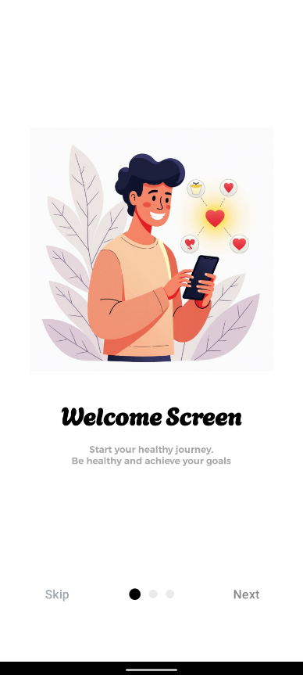

1. **Login/Sign Up Screen (SignUpLoginScreenActivity):**
   * **Description:** Presents three prominent buttons: "Sign In with Email," "Sign Up with Email," and "Admin Sign In." Often includes a background image or a clean, minimalist design.
   * **Purpose:** Acts as a gateway for users to either log in, register, or for administrators to access their panel.
   * 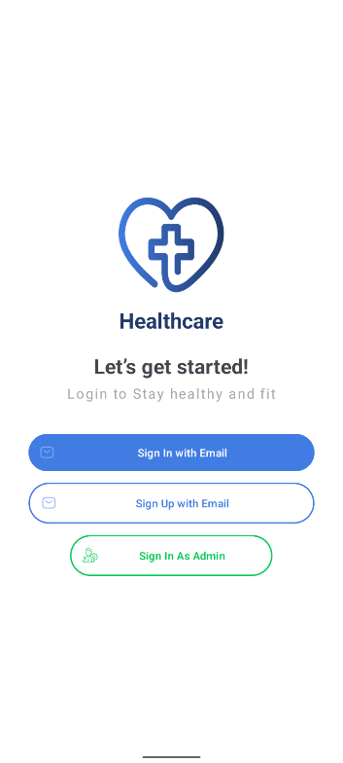
2. **Sign In Activity (SignInActivity):**
   * **Description:** Input fields for Email and Password, a "Forgot Password?" text link, and a "Sign In" button. A smaller text link "Don't have an account? Sign Up" is usually present.
   * **Purpose:** Authenticates existing users.

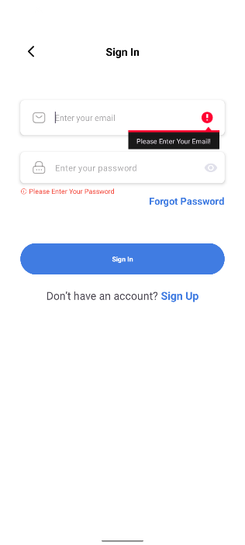

1. **Sign Up Activity (SignUpActivity):**
   * **Description:** Input fields for User Name, Email, and Password, along with a "Sign Up" button.
   * **Purpose:** Allows new users to create an account.

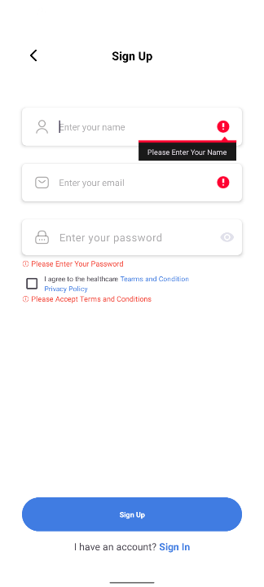

1. **User Info Activity (UserInfoActivity):**
   * **Description:** A multi-step form (likely a ViewPager with different layouts per page) to collect detailed user health information: Gender, Age-Blood Group, Height-Weight-Address, Activity Level (Sedentary, Moderate, Active). Includes "Next" and "Back" navigation buttons, culminating in a "Finish" button.
   * **Purpose:** Gathers essential health data for personalized features and health calculations.

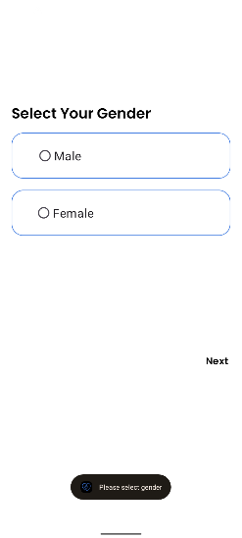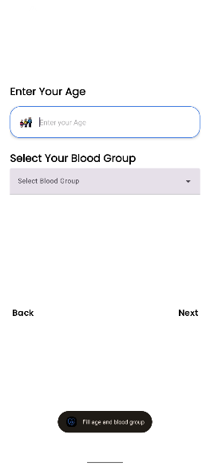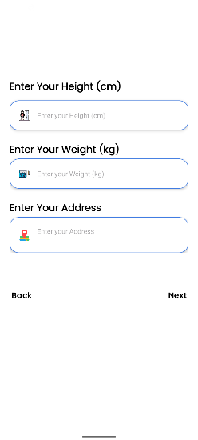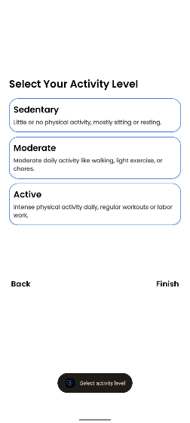

1. **Dashboard Activity (User - Home Fragment):**
   * **Description:** Top section: User's Name and Profile Image. Below: A prominent search card for medicines. Below that: Horizontal row of service buttons (Doctor, SOS, Nearby Hospital, Nearby Medical). Further down: "E-News" section with news headlines from Newsdata.io. Bottom: Horizontal scrollable lists for "Top 5 Medicines" and "Top 5 Doctors." Features a large floating action button (FAB) in the center bottom for "Ai Chat."
   * **Purpose:** The central landing page, providing quick access to all major features and an overview of health information and news.

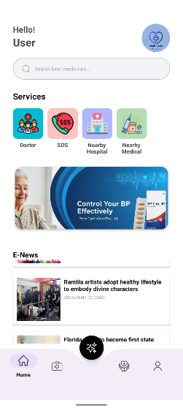

1. **Medicine Fragment:**
   * **Description:** Title "Medicines" at the top, with a cart icon in the top right. A search card view for medicines below. A banner advertisement section. Below that, "Popular Products" with a horizontal recycler view, and "Medicines" with a vertical recycler view showing all available medicines. "See all" links are present for popular/all medicines.
   * **Purpose:** Facilitates browsing, searching, and discovering medicines.

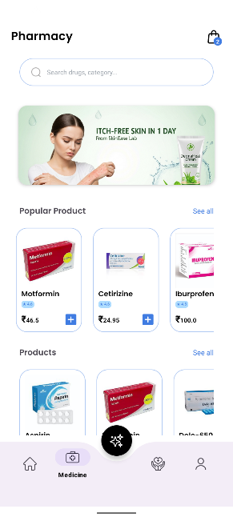

1. **Ai Chat Activity (AiChatActivity):**
   * **Description:** A chat interface similar to messaging apps, with a text input field at the bottom and a "Send" button. Displays conversational bubbles for user queries and AI responses (powered by OpenRouter API).
   * **Purpose:** Provides interactive health advice and answers to user queries using AI.

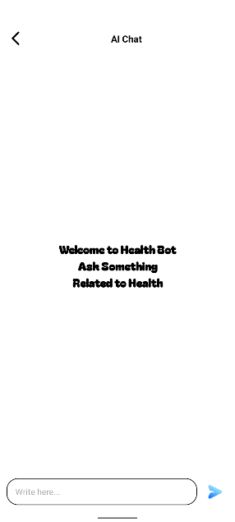

1. **Health Fragment:**
   * **Description:** Title "Health" at the top. Below: Card views for various health metrics like "Max Heart Rate" (clickable), "Blood Group," "Age," "Height," "Weight," "BMI," "BMR," "TDEE," and "Water Intake." Each metric is clearly labeled with its calculated value.
   * **Purpose:** Presents a summary of the user's health metrics and offers tools for health tracking.

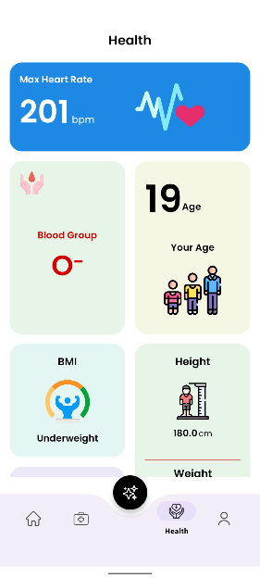

1. **Profile Fragment:**
   * **Description:** Top section: "Profile" title with "Settings" and "Notification" icon buttons. Below: A large card view displaying User Image, Name, Email, and an "Edit Profile" button. Further down: Linear layouts (or list items) for "Top Doctor," "Top Medicine," "Ai Chat," "Log Out," etc.
   * **Purpose:** Allows users to view and manage their profile, access settings, and navigate to key sections.

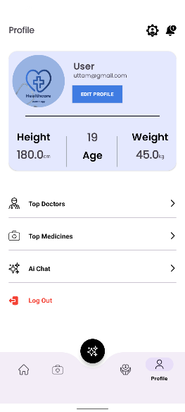

1. **Doctor Details Activity (DoctorDetailsActivity):**
   * **Description:** Displays a large image of the doctor. Below: Doctor's Name, Job Title, Rating. Then, contact information (WhatsApp, Phone, Instagram icons/links), Location, and a detailed "Description" section.
   * **Purpose:** Provides comprehensive information about a specific doctor.

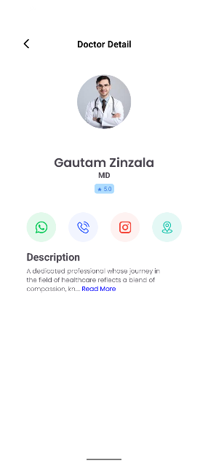

1. **Cart Activity (CartActivity):**
   * **Description:** Lists items added to the cart, showing medicine image, name, price, and quantity. Buttons to increase/decrease quantity. Displays a total price summary at the bottom, with a "Proceed to Order" button.
   * **Purpose:** Manages the user's selected medicines before purchase.

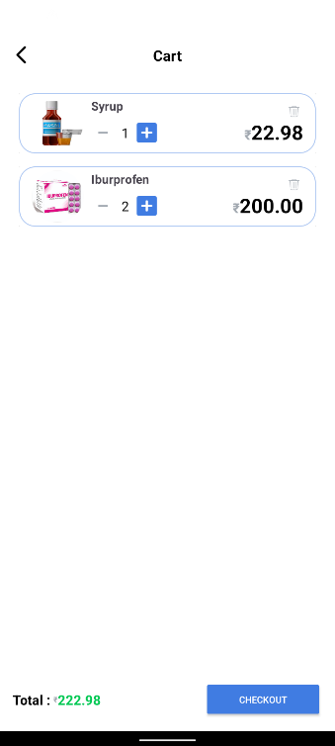

**13.2. Admin Screens**

1. **Admin Sign In Activity (AdminSignInActivity):**
   * **Description:** Similar to the user sign-in screen but branded for admin access. Input fields for Admin Email and Password, and a "Sign In" button.
   * **Purpose:** Authenticates administrators to access the management panel.

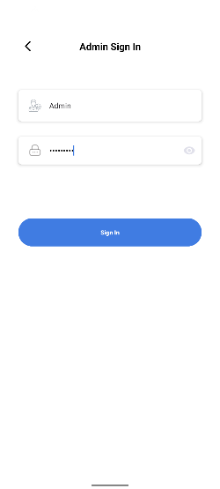

1. **Admin Dashboard Activity (Admin Home Fragment):**
   * **Description:** Title "Admin Home." Below: Three card views displaying "Total Users," "Total Doctors," and "Total Medicines" with their respective counts. Further down: A section for "5 New Doctors" (horizontal recycler) and "5 New Users" (vertical recycler), showcasing recent additions.
   * **Purpose:** Provides an overview and key statistics for the administrator.

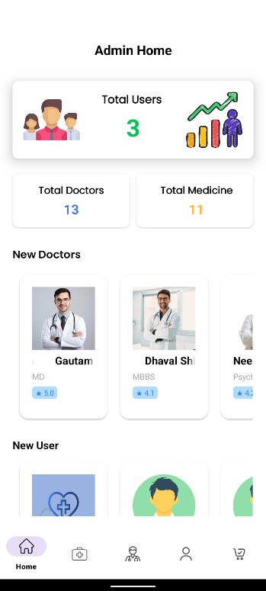

1. **Admin Medicines Fragment:**
   * **Description:** Title "Medicines." A search card view with an input field and search button. Below: A recycler view listing all medicines with their Name, Image, Price, Category. At the bottom right, a floating action button (FAB) labeled "+" for "Add Medicine."
   * **Purpose:** Allows administrators to view, search, and add medicines. Clicking on a medicine item navigates to update/delete screen.

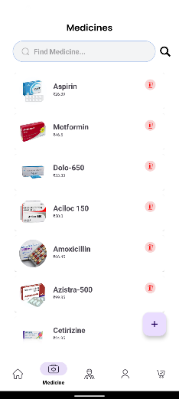

1. **Admin Add Medicines Activity (AdminAddMedicinesActivity):**
   * **Description:** Input fields for Medicine Name, Price, Category, Expiry Date, Description, Rating. An image picker/upload section. A "Save" button.
   * **Purpose:** To add new medicine entries to the database.

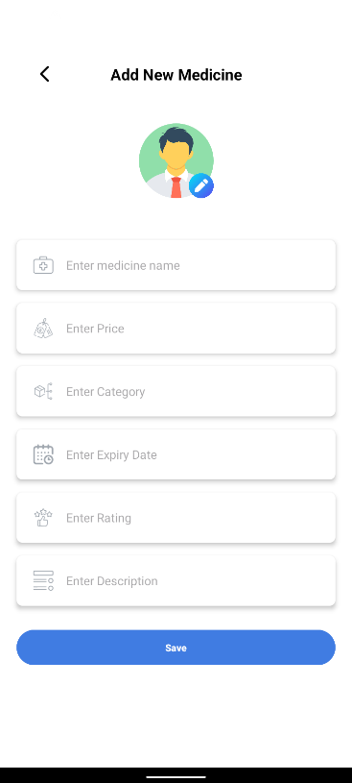

1. **Update Medicines Activity (UpdateMedicinesActivity):**
   * **Description:** Pre-filled input fields with existing medicine details (Name, Price, Category, Expiry Date, Description, Rating). Image display. "Update" and "Delete" buttons.
   * **Purpose:** To modify or remove existing medicine details.

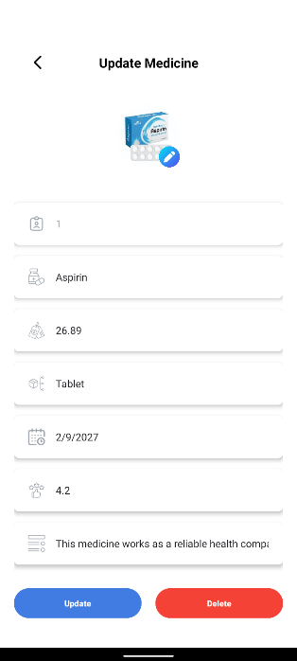

1. **Admin Medicine Order Fragment:**
   * **Description:** Title "Medicine Order." Below: A recycler view listing all orders, showing User ID, Medicine Name, Quantity, Order Date.
   * **Purpose:** To review all medicine orders placed by users. Clicking an order leads to details and cancellation option.

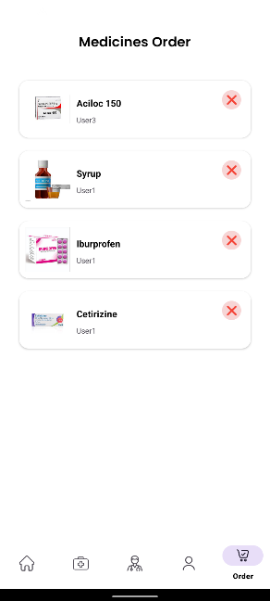

1. **Admin Medicine Order Details Activity (AdminMedicineOrderDetailsActivity):**
   * **Description:** Displays detailed information about a specific order, including User Name, Medicine Name, Quantity, Price, Order Date. A "Cancel Order" button is prominently displayed.
   * **Purpose:** Provides granular view of an order and allows cancellation.

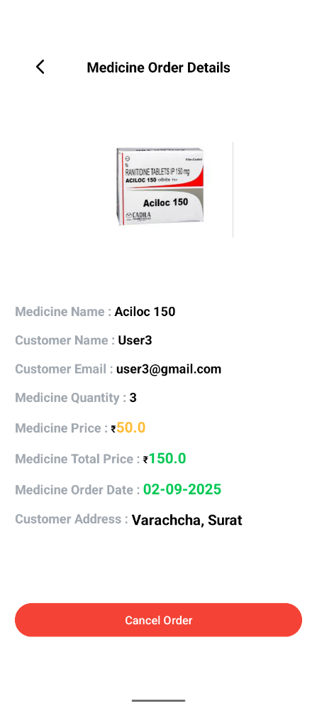

**12. System Testing**

System testing is a crucial phase in software development to ensure that the integrated application works as intended and meets the specified requirements. For the Health Care App, a systematic approach to testing is vital to guarantee functionality, reliability, usability, and security for both user and admin modules.

**12.1. Types of Testing**

1. **Unit Testing:**
   * **Focus:** Testing individual components or methods (units) in isolation.
   * **Application:** Verifying the correctness of specific Java functions, database helper methods (e.g., addUser(), getMedicine()), API call methods, and input validation logic.
   * **Example:** Test if the password hashing function works correctly, or if a date parsing utility returns the expected format.
2. **Integration Testing:**
   * **Focus:** Testing the interactions between different modules or components of the application.
   * **Application:** Ensuring that the database methods correctly interact with the UI logic, that API calls return data in the expected format, and that data flows smoothly between activities/fragments.
   * **Example:** Testing if after a user signs up, their data is correctly stored in the SQLite database and can be retrieved for login. Testing if the AI Chat activity correctly sends queries to OpenRouter API and displays responses.
3. **System Testing:**
   * **Focus:** Testing the complete, integrated application to verify that it meets the overall requirements and performs as expected in an end-to-end scenario.
   * **Application:** Simulating real-world usage for both Admin and User roles. This involves testing the entire flow from app launch to complex scenarios involving multiple features and external interactions.
   * **Example:** A user registers, logs in, searches for a medicine, adds it to the cart, proceeds to order. An admin then logs in, views the order, and cancels it, and the user receives a notification.
4. **User Acceptance Testing (UAT):**
   * **Focus:** Involving actual end-users (or representatives of the target audience) to test the application in a real-world environment to validate its suitability for use.
   * **Application:** Users and (potentially) mock administrators would test the app's usability, functionality, and performance from their perspective to ensure it meets their needs and expectations.
   * **Example:** Providing beta access to a group of potential users and asking them to perform specific tasks (e.g., "Find a doctor specializing in cardiology," "Reset your password") and provide feedback on their experience.
5. **Functional Testing:**
   * **Focus:** Verifying that each function of the application operates according to the specifications.
   * **Application:** Testing every button, input field, navigation link, and core feature (e.g., "SOS" button dials 108, "Nearby Hospital" opens Google Maps, Admin's "Delete User" successfully removes a user).
6. **Non-Functional Testing:**
   * **Performance Testing:** Assessing speed, responsiveness, and stability under various conditions (e.g., how fast screens load, how quickly API responses are processed).
   * **Usability Testing:** Evaluating how easy and intuitive the app is to use.
   * **Security Testing:** Identifying vulnerabilities (e.g., weak password storage, unencrypted data transmission for sensitive info, though basic for this project).
   * **Compatibility Testing:** Ensuring the app works across different Android versions (minSdk 28, targetSdk 35) and device screen sizes.

**12.2. Example Test Cases**

Here are a few example test cases for critical functionalities:

**Test Case 1: User Registration**

* **Feature:** User Sign Up
* **Test ID:** USR_REG_001
* **Description:** Verify a new user can successfully register and their profile data is stored.
* **Preconditions:** App is launched on Login/Sign Up Screen.
* **Steps:**
  1. Click "Sign Up with Email."
  2. Enter valid Name, Email (unique), Password in SignUpActivity.
  3. Click "Sign Up."
  4. Proceed to UserInfoActivity. Fill all required fields (Gender, Age, Blood Group, Height, Weight, Address, Activity Level).
  5. Click "Finish."
* **Expected Result:** User is successfully registered, data stored in TABLE_USER, and redirected to DashboardActivity.

**Test Case 2: User Login (Valid Credentials)**

* **Feature:** User Sign In
* **Test ID:** USR_LOG_001
* **Description:** Verify an existing user can log in with correct credentials.
* **Preconditions:** A user account exists in TABLE_USER. App is on Login/Sign Up Screen.
* **Steps:**
  1. Click "Sign In with Email."
  2. Enter valid Email and Password for an existing user.
  3. Click "Sign In."
* **Expected Result:** User is successfully logged in and redirected to DashboardActivity.

**Test Case 3: AI Chat Functionality**

* **Feature:** Ai Chat
* **Description:** Verify AI chat correctly processes queries and provides responses via OpenRouter API.
* **Preconditions:** User is logged in and has internet connectivity.
* **Steps:**
  1. Navigate to DashboardActivity.
  2. Click the central FAB for "Ai Chat."
  3. In AiChatActivity, type a health-related query (e.g., "What are the symptoms of common cold?").
  4. Click "Send."
* **Expected Result:** The AI chatbot displays a relevant and coherent response to the query.

**Test Case 4: Admin Add New Medicine**

* **Feature:** Admin Medicine Management
* **Test ID:** ADM_MED_001
* **Description:** Verify Admin can successfully add a new medicine.
* **Preconditions:** Admin is logged into AdminDashboardActivity.
* **Steps:**
  1. Navigate to AdminMedicinesFragment (using bottom nav).
  2. Click the "+" FAB to add a new medicine.
  3. In AdminAddMedicinesActivity, enter all required details (Name, Price, Category, ExpiryDate, Rating, Description) and upload an image.
  4. Click "Save."
* **Expected Result:** New medicine is added to TABLE_MEDICINE, and it appears in the list in AdminMedicinesFragment.

**Test Case 5: Admin Cancel Order**

* **Feature:** Admin Order Management
* **Test ID:** ADM_ORD_001
* **Description:** Verify Admin can cancel an existing order and user receives notification.
* **Preconditions:** An order exists in TABLE_MEDICINE_ORDER. Admin is logged into AdminDashboardActivity.
* **Steps:**
  1. Navigate to AdminMedicineOrderFragment (using bottom nav).
  2. Select an existing order from the list to open AdminMedicineOrderDetailsActivity.
  3. Click "Cancel Order" button.
* **Expected Result:** The order is deleted from TABLE_MEDICINE_ORDER. A notification entry for cancellation is added to TABLE_NOTIFICATION for the respective user.

**13. Limitations of Current System**

While the Health Care App offers a range of functionalities for a college project, it inherently comes with certain limitations due to its design, chosen technologies, and scope. Addressing these would typically be part of future enhancements.

1. **Local Database (SQLite) Limitations:**
   * **No Multi-User/Real-Time Sync:** Data is stored locally on each device. There's no centralized database, which means user data cannot be accessed across multiple devices, and admin changes aren't immediately reflected to all users without manual updates or a sync mechanism (not implemented).
   * **Scalability for Data:** Not suitable for large-scale applications with millions of users and extensive data.
   * **Backup and Recovery:** Data is tied to the device. If the device is lost or damaged, user data could be lost unless specific backup mechanisms (not explicitly mentioned) are implemented.
   * **Security:** Local SQLite databases can be vulnerable if the device is rooted or compromised, making data potentially accessible to unauthorized parties.
2. **Security and Authentication:**
   * **Basic Authentication:** The system relies on email and password. There's no mention of advanced security features like two-factor authentication (2FA), biometric login, or OAuth for third-party logins, which are standard in modern apps.
   * **Password Storage:** While TEXT NOT NULL is specified, it's crucial that passwords are not stored in plain text but are hashed and salted for security. (This is an implementation detail not covered by schema).
   * **Data Encryption:** No explicit mention of encrypting sensitive data (like user health information) at rest within the SQLite database.
3. **No Server-Side Logic:**
   * The app is primarily client-side. There's no dedicated backend server for complex business logic, user management beyond local device, or push notifications. This restricts features requiring server-initiated actions or complex data processing.
4. **Notifications:**
   * The NOTIFICATION table suggests an internal notification system. However, there's no explicit mention of **push**, which are standard for real-time alerts to users even when the app is closed.
5. **Payment Gateway:**
   * A PaymentSuccessActivity is listed, but there's no mention of an actual payment gateway integration (e.g., Stripe, PayPal, Razorpay). This implies the payment process is conceptual or a placeholder in the current system.
6. **SOS Functionality:**
   * While "SOS" dials 108, it's a basic call. There's no integration for sending location data to emergency contacts, or alerting pre-defined emergency services automatically, which would enhance a real-world SOS feature.
7. **Google Maps Integration:**
   * The current implementation "redirects on Google Map," suggesting it opens the external Google Maps app. Full in-app map integration with custom markers, routing, and interactive elements would provide a richer user experience.
8. **AI Chat API Dependency:**
   * Reliance on OpenRouter API means the AI chat functionality is dependent on the external service's availability, performance, and potential costs.
9. **Admin Panel Accessibility:**
   * The admin panel is within the same mobile app. For a larger system, a dedicated web-based admin portal is usually preferred for better manageability, security, and richer data visualization.
10. **Scalability for Services:**
    * The current approach of directly querying APIs from the client might face limitations in terms of rate limits or security if not properly managed through a backend proxy for large user bases.
11. **No Doctor Appointment Booking:**
    * The app provides doctor details but does not offer direct appointment booking or consultation scheduling through the platform.

**14. Future Enhancement**

To evolve the Health Care App into a more robust, scalable, and feature-rich platform, several enhancements can be considered. These improvements would address the current limitations and introduce advanced functionalities.

1. **Cloud-Based Database Integration:**
   * **Replace SQLite with:** Firebase Realtime Database/Firestore, AWS Amplify, MongoDB Atlas, or a custom backend with PostgreSQL/MySQL.
   * **Benefits:** Enables multi-device sync, real-time data updates, improved scalability, centralized data management, and robust backup/recovery solutions.
2. **Enhanced User Authentication and Security:**
   * **Two-Factor Authentication (2FA):** Add an extra layer of security using SMS OTPs or authenticator apps.
   * **Biometric Authentication:** Integrate fingerprint or face ID login for convenience and security.
   * **Social Logins:** Allow sign-in/sign-up using Google, Facebook, etc., via Firebase Authentication or other identity providers.
   * **Data Encryption:** Implement stronger encryption for sensitive user data, both at rest and in transit.
3. **Real-time Push Notifications:**
   * **Integrate Firebase Cloud Messaging (FCM):** For sending real-time notifications to users about order status, health reminders, new news, or important alerts, even when the app is closed.
   * **Personalized Alerts:** Implement intelligent notification triggers based on user activity, health goals, or medicine refills.
4. **Payment Gateway Integration:**
   * **Integrate third-party payment SDKs:** Implement secure payment processing using popular gateways like Stripe, Razorpay, PayPal, or Google Pay.
   * **Order Tracking:** Provide users with real-time order tracking functionality.
5. **Telemedicine & Online Consultations:**
   * **Video/Audio Call Integration:** Allow users to book and have virtual consultations with doctors directly through the app (e.g., using Twilio, Agora.io, or Jitsi Meet SDKs).
   * **In-app Messaging:** Enable secure chat between users and doctors for follow-ups.
6. **Wearable Device Integration:**
   * **Health Kit APIs (e.g., Google Fit):** Integrate with health platforms to sync data from smartwatches and fitness trackers (e.g., heart rate, step count, sleep patterns) for more accurate health tracking.
7. **Advanced AI/ML for Personalized Health:**
   * **Predictive Analytics:** Use AI to predict potential health risks based on user data.
   * **Personalized Health Recommendations:** Offer tailored advice on diet, exercise, and preventative care.
   * **Symptom Checker:** An advanced AI-powered symptom checker that suggests possible conditions and when to consult a doctor.
8. **Enhanced SOS Features:**
   * **Emergency Contact Alerts:** Automatically send SMS/email alerts with user's location to predefined emergency contacts.
   * **GPS Tracking for Emergency Services:** Share live location with emergency services upon activation.
9. **Appointment Booking System:**
   * **In-App Doctor Appointments:** Allow users to view doctor availability, book, reschedule, and cancel appointments directly.
   * **Calendar Integration:** Sync appointments with user's device calendar.
10. **Community and Educational Features:**
    * **Health Forums/Blogs:** Create a platform for users to discuss health topics, share experiences, and access curated health articles.
    * **Health Campaigns:** Promote awareness campaigns and educational content.
11. **Robust Admin Web Panel:**
    * **Dedicated Web Interface:** Develop a secure, feature-rich web-based admin portal for comprehensive management of users, doctors, medicines, orders, content, and analytics, providing better UI/UX for administrative tasks than a mobile app.
12. **Multi-language Support:**
    * **Internationalization:** Support multiple languages to cater to a broader global audience.
13. **Accessibility Features:**
    * **WCAG Compliance:** Ensure the app is accessible to users with disabilities (e.g., screen reader support, larger text options, color contrast).
14. **User Feedback and Rating System:**
    * **Structured Feedback:** Implement a robust system for users to provide feedback on doctors, medicines, and the app itself.
    * **Doctor Review Management:** Allow admins to manage and respond to doctor reviews.
15. **Inventory Management (for Medicines):**
    * **Stock Tracking:** Add features to track medicine stock levels, trigger reorder alerts for admins, and show real-time availability to users.